Table of Contents

Description 1

Control Description 1

Interface Sketch 2

Initial Scene 2

Game Over 2

Screen Description 3

Initial Start Scene 3

Gameplay 3

Game Over 4

Enemies 4

Scoring 4

Sound Index 5

Coin Pickup 5

Enemy Ship Crash 5

Laser shot 5

Art/Multimedia Index 6

Background 6

Player Ship 6

Meteor 6

## Description

This is a side-scrolling 2D shooter game. You control a spaceship with the objective of destroying enemy ships and collecting stars in order to achieve a high score. Alongside the enemy ships there are meteors which you must avoid at all costs but you may use your laser cannon to take out enemy ships. If you collide with meteors and/or enemies too many times, your life points will reach 0, in which case, your ship will be destroyed and you will be meet with a “Game Over” screen, displaying your high score and a “Play Again” button.

## Control Description

WASD – Movement of Ship

SPACE – Fire Laser

## Interface Sketch

### Initial Scene

LIFE

SCORE

SHIP

### Game Over

BUTTON

HIGH SCORE

GAME OVER

## Screen Description

### Initial Start Scene

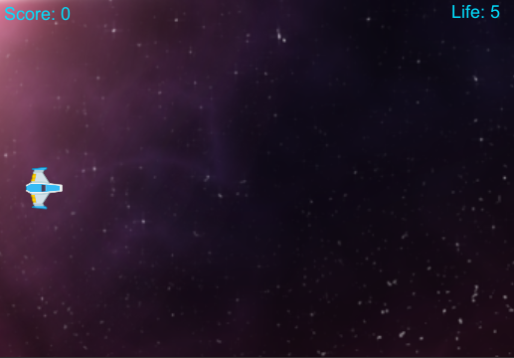

### Gameplay

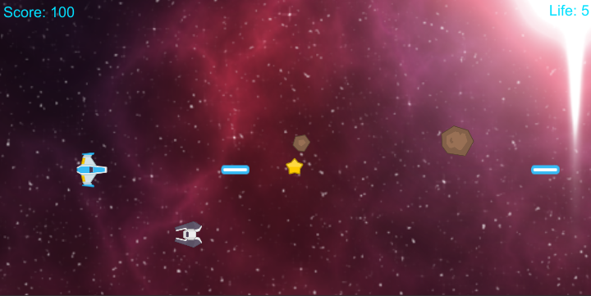

### Game Over

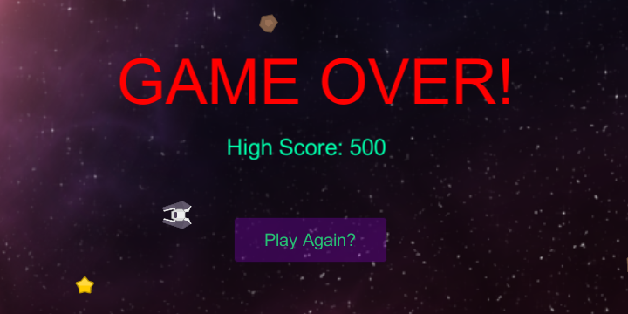

## Enemies

There are two instances that can damage your ship. The first is a moving AI that flies across the screen from right to left. The other is two meteors varying from two different sizes which spawn randomly and rain down from top to bottom.

## Scoring

The only way to get points in this game is by collecting stars which shoot across your screen. Each time a star is collected by a player, they are awarded with 100 points. The star only moves in one direction(right to left) and randomly spawns again once the player has collected it or it has moved out of frame.

## Sound Index

### Coin Pickup

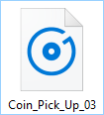

### Enemy Ship Crash

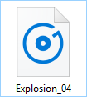

### Laser shot

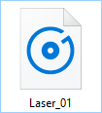

Art/Multimedia Index

### Background

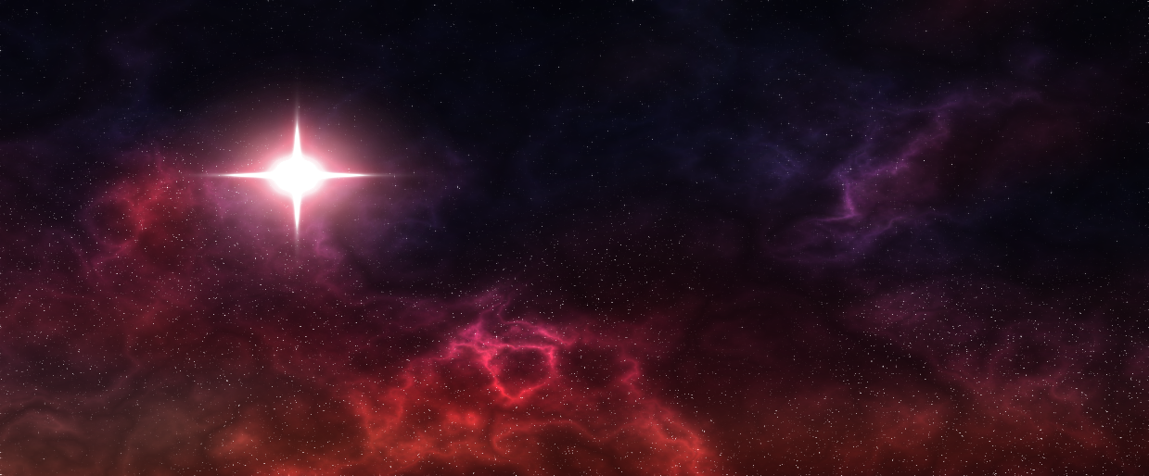

Player Ship Enemy Ship

 

Meteor Star

 